Local Registration: Steps and Requirements (using an Access Database on an IIS server)
Using a simple Access Database, you can easily host registration on your campus servers. We can provide a single “register.asp” file that handles both the registration requirements as well as synchronization with the i>grader program. This .asp file can be configured to allow either open or authenticated registration. The data can be stored in either an Access database (standard on all IIS servers) or a SQL database. We’ve outlined the steps and requirements for hosting i>clicker registration locally using an IIS server below.

Server Requirements:
Hardware
Processor \ Mother Board: Intel Pentium IV (2.0 Ghz) or Higher.
Ram: 2 GB or Higher.
HDD: 100 GB or Higher.
Software
Operating System: Microsoft Windows 2000 Server/Advanced Server with Service Pack 4 Or Microsoft Windows 2003 server with Service Pack 1
Web Server: IIS 5.0 for Windows 2000 & IIS 6 for Windows 2003
Other
The default communication port (80) should be open.

Installation Instructions:
CAVEAT: These are general guidelines but every university may have unique or customized settings. Please consult your system or security administrator before performing the below steps.

- Make sure you have the complete i>clicker registration zip folder (localregistration.zip)
and save the files (register.asp, clickers.mdb) onto your computer (in an easily retrievable location).

- From your “Control Panel,” click on “Administrative Tools.”
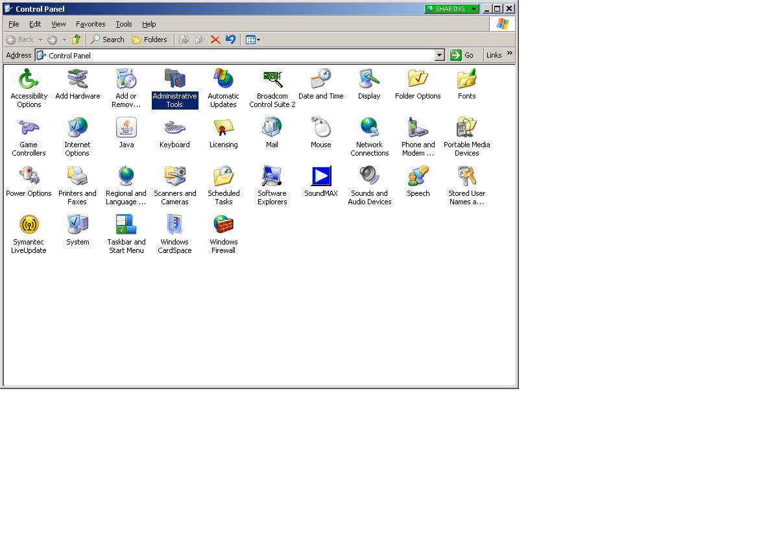

3. Locate “Internet Information Services” from your “Administrative Tools’ menu.
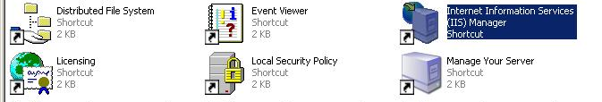

4. Locate and select Default Web Site (or wherever you want to host the registration page on your server). Right click on “Default Web Site,” locate “New” and select “Virtual Directory.” A “Virtual Directory Creation Wizard” will open.
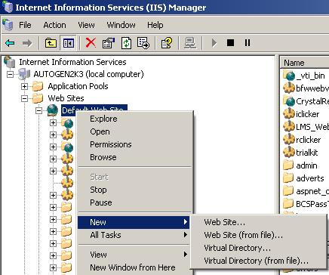
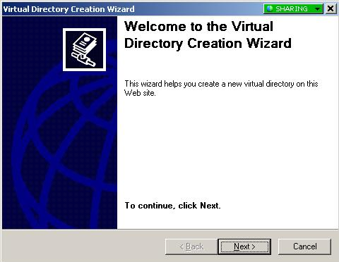

- Proceed through the Virtual Director Wizard Screens.
- Under “Alias,” enter in the alias you want to use to gain access to the virtual director (e.g. Clicker Registration) and click “Next”
- Under “Web Site Content Directory,” browse for the folder that contains register.asp and clickers.mdb files: and
  - Copy the .ASP registration page into the source of the directory
  - Copy the .MDB file on the machine accessible from the virtual directory
- Under “Virtual Directory Access Permissions,” make sure “Read,” “Run Scripts,” and “Execute (such as ISAPI applications or CGI)” are all checked and click “Next”.
- Click on “Finish.”

- Return to the main IIS Manager page. Under the “Web Services Extensions” tab, make sure the following extensions are set to “Allowed”:
  - Active Server Pages
  - Server Side Includes
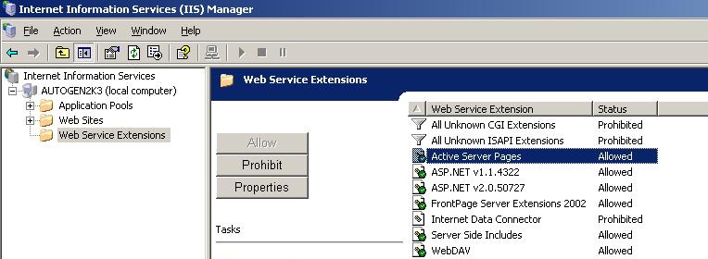
- Return to the main IIS Manager page. Go to “Web Sites” > “Default Web Sites> and locate your Alias (e.g. Clicker Registration) folder. On the right window, right click on “Register.asp” and select “Browse.”
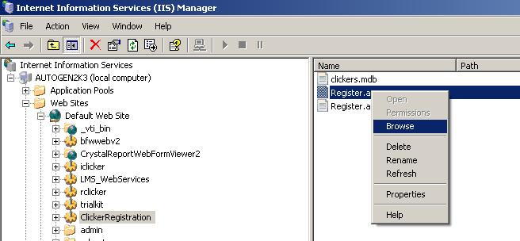

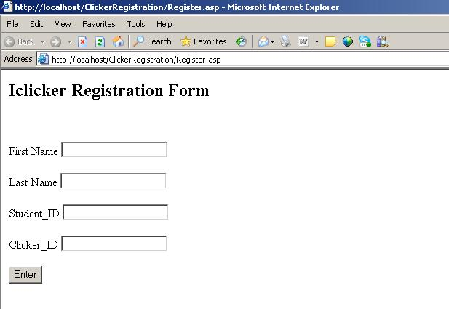
- Return to the main IIS Manager page. Go to “Web Sites” > “Default Web Sites> and locate your Alias (e.g. Clicker Registration) folder. On the right window, right click on “Register.asp” and select “Browse.”

You will then be taken to your i>clicker registration form. From here, you may want to test the asp registration page (enter in a dummy student and i>clicker ID). Note: there is a checksum on this page so that invalid clicker remote IDs won’t be allowed.

- Of course, you may design this page to better match your institution’s or department’s web site look and feel.

10. You can also leverage your school’s authentication process during i>clicker remote registration. If you have your students first authenticate by logging into your school's system, you can use that information to pre-populated the student information, so all they need to do is enter their clicker ID. This method virtually eliminates any student errors with online registration."

Local Registration: Your Instructor’s Experience
The instructor experience using a locally hosted web registration solution is very similar to the national web site registration solution.

What remains the same?
Once students have registered online, every instructor will need to synchronize their students’ registrations with their desk top application of i>grader.

What is different?
Instructors using locally hosted registration need their i>grader software to synchronize registrations with your local database rather than our national database.
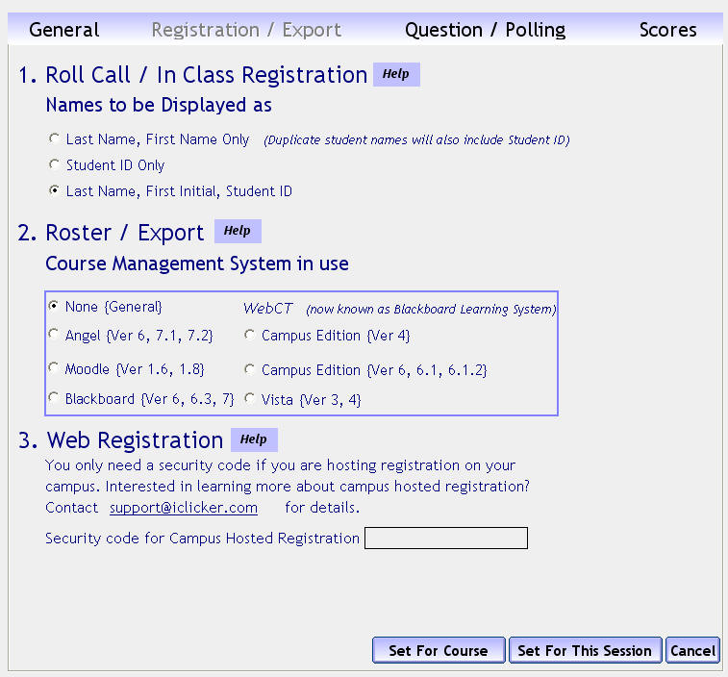
To enable local web synchronization, faculty will need to:

1. Open the i>clicker application and go to “Your Settings and Preferences.” Locate the “Registration/Export” tab.

2. Under “3. Web Registration,” enter a code (or more likely an adapted URL) provided by you. This code is actually an adapted version of your campus registration URL.

So, for example, if your registration URL:
http://www.clicker.uiuc.edu/register
your “security code” would be:
sqlhttp://www.clicker.uiuc.edu/register

Note that the adapted address begins with an SQL prefix, even if you are using the Access database.

- Locate and select “Set for Course”

When the instructor synchronizes her web registrations through i>grader, i>grader will then search out the local campus URL/database rather than our national web registration database.

Note: If a student has not voted with their i>clicker remote, the online registration will not synchronize with a professor’s i>grader application. The student must vote at least once in class before their clicker registration will be synchronized.

